**Computer Networks Lab 6**

**Name: Vaibhav Chaudhari**

**ID: 2017B5A70834G**

**Write a TCP server and a client for the following.  
1. The server as a command line argument accepts the port number to which it should bind. (1 mark)**

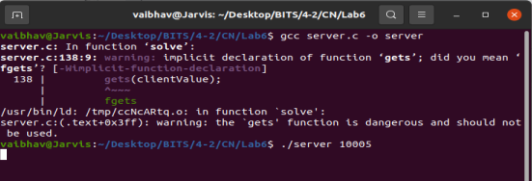

The server accepts 10005 as the port number to which it will bind. **2. The client, as command line arguments, accepts the IP address and the port number at which it will find the server. (1 mark)**

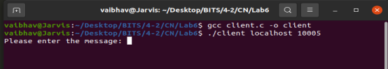

The Client accepts the IP Address as localhost as server running on localhost and port number as 10005 at which server is running. **3. After connecting to the server, the client reads a line from the standard input and sends it to the server. (1 mark)**

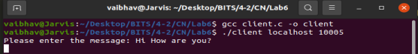

**4. The server prints the received line in the reverser order (2 marks) and reads a line from the standard input and sends it to the client or all the clients. (1 mark)**

**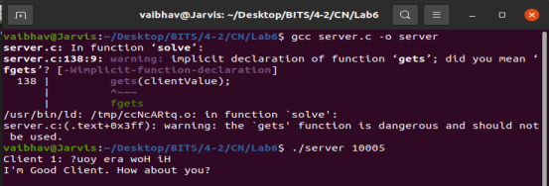  
5. The client prints the received line in the reverse order and is ready to accept a new line from the user. (2 marks)**

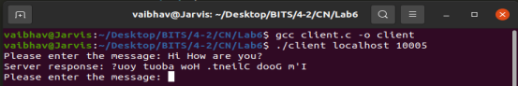

**6. The client exits if the user type "exit". (1 mark)**

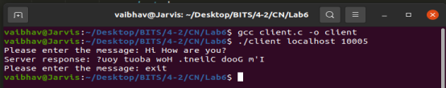

The client exits and sends this info to the server.

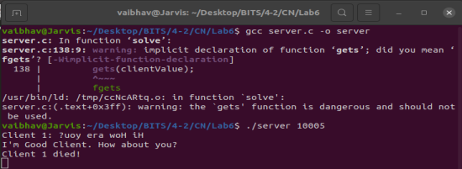

The server shows which client exited.

**7. The server at a time accepts at the most four clients. (4 marks) Any client above the limit is rejected. (4 marks) As and when the number is less than the limit, the server accepts the new client. (2 marks)**

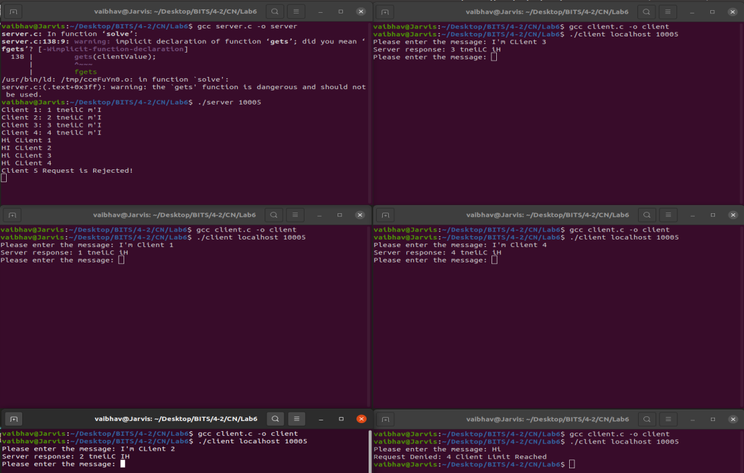

At most 4 clients are accepted by the server as seen in the above screenshot i.e. Client 1, 2, 3 and 4. The server sends the messages it receives from the standard input to the respective client as seen in the above picture.

When the 5th Client denoted by the bottom right terminal wants to join, the server rejects the client as seen in the top left terminal and when the client sends some message, server returns “Request Denied: 4 Client Limit Reached” and the client automatically exits.

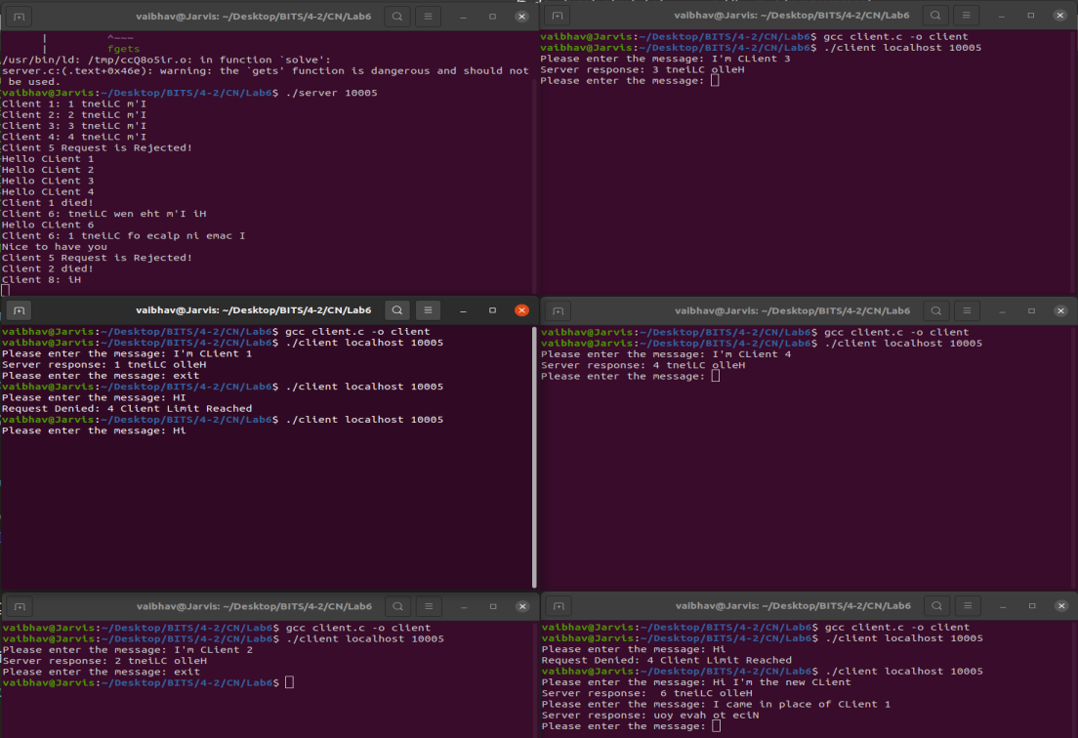

In this picture, first the 4 clients join and send messages to the server. The server rejects the 5th Client that wants to join as seen in bottom right and top left terminal. Then the server sends back the messages to the respective client.

Now we exit using the Client 1 as the server shows that the client 1 died. Now the active clients connected to the server are 3 so we have space for 1 more client. Now the bottom right terminal again connects to the client and is successful as the 6th Client. It is able to send and receive the messages from the server. The active client at the moment are Client 2, 3, 4 and 6.

Now the 2nd terminal on the left again wants to connect to the client but since 4 clients are already there it is not able to connect as the 7th Client. We then exit using the Client 2 as it can be seen from the image above where server shows that Client 2 died. Now the active clients connected to the server are 3 so we have space for 1 more client. Now the 2nd terminal on the left again connects to the client and is successful as the 8th Client. It is able to send and receive the messages from the server. The active client at the moment are Client 3, 4, 6 and 8.\

**THIS CLEARLY SHOWS THAT THE MAXIMUM NUMBER OF CLIENTS AT A MOMENT CAN ONLY BE 4 AND ADDITIONAL CLIENTS ARE REJECTED BY THE SERVER. IF A CLIENT EXITS, THERE IS SPACE FOR A CLIENT AND A DIFFERENT CLIENT CAN JOIN UNTILL THERE ARE MAXIMUM OF 4 CLIENTS AGAIN. THEREFORE, WHEN THE NUMBER OF CLIENTS ARE LESS THAN THE LIMIT, THE SERVER ACCEPTS THE NEW CLIENT.**